What are our preferred learning styles?
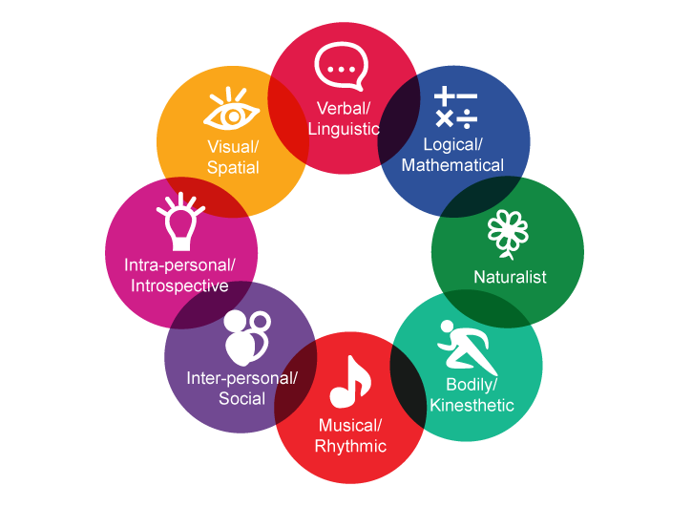

Learning style | Strengths | Characteristics
Verbal - Linguistic | Words, Language and Writing  People who are strong in linguistic-verbal intelligence are able to use words well, both when writing and speaking. These individuals are typically very good at writing stories, memorizing information and reading.
Logical - Mathematical | Analysing Problems and Mathematical Operations  People who are strong in logical-mathematical intelligence are good at reasoning, recognizing patterns and logically analyse problems. These individuals tend to think about numbers, relationships and patterns.
Interpersonal | Understanding and Relating to Other People  Those who have strong interpersonal intelligence are good understanding and interacting with other people. These individuals are skilled at assessing the emotions, motivations, desires and intentions of those around them.
Intrapersonal | Introspection and Self-Reflection  Individuals who are strong in intrapersonal intelligence are good at being aware of their own emotional states, feelings and motivations. They tend to enjoy self-reflection and analysis, including day-dreaming, exploring relationships with others and assessing their personal strengths.
Musical | Rhythm and Music  People who have strong musical intelligence are good and thinking in patterns, rhythms and sounds. They have a strong appreciation for music and are often good at musical composition and performance.
Visual - Spatial | Visual and Spatial Judgment  People who are strong in visual-spatial intelligence are good a visualising things. These individuals are often good with directions as well as maps, charts, videos and pictures.
Naturalistic | Finding Patters and Relationships to Nature  Individuals who are high in this type of intelligence are more in tune with nature and are often interested in nurturing, exploring the environment and learning about other species. These individuals are said to be highly aware of even subtle changes to their environments.
Bodily - Kinesthetic | Physical Movement, Motor Control  Those who have high bodily-kinesthetic intelligence are said to be good at body movement, performing actions and physical control. People who are strong in this area tend to have excellent hand-eye coordination and dexterity.

Activity: Take the learning style test to see your preferred learning styles: http://www.bgfl.org/bgfl/custom/resources_ftp/client_ftp/ks3/ict/multiple_int/index.htm

List your top 2 preferred learning styles:

List least preferred learning style:

